17.3.3 Editors - Graph Editor - Sidebar - View Tab
Sidebar - View tab 1
Show Cursor panel 1
Show Cursor checkbox 1
Cursor X 1
Cursor Y 2
Cursor to Selection 2
Marker options panel 2
Lock Markers 2
Sidebar - View options panel 2
Realtime Updates 2
Show Markers 2
Show Seconds 2
Sync visible range 2
Show Sliders 2
Show Group Colors 3
AutoMerge Keyframes 3
Use High Quality Display 3
Show Handles 3
Only selected Curve Keyframes 3
Only Selected Keyframes Handles 3

Sidebar - View tab
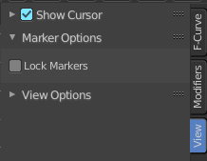
The view tab contains further options.

Show Cursor panel

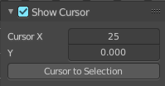
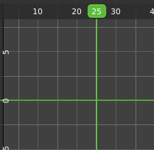
The vertical green line is the time cursor. The horizontal green line is called the cursor. Or groundline cursor. Together they are the 2d cursor.

Show Cursor checkbox
Hides the green groundline cursor.

Cursor X
The frame position of the playhead cursor.

Cursor Y
The Y position of the groundline cursor.

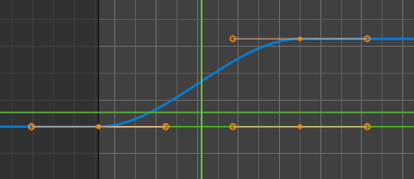
Cursor to Selection
Sets both cursors to the center of the selection. This button also works when the groundline cursor is deactivated. In this case just the playhead cursor gets set to the center of the selection.

Marker options panel

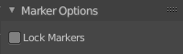
Lock Markers
Make the markers uneditable.

Sidebar - View options panel
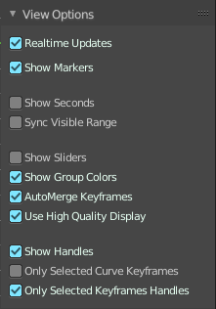
Some of these settings belongs to the Graph editor. But can also be changed from the Dope Sheet editor.

Realtime Updates
When transforming keyframes then this transformation is also immediately visible in other editors.

Show Markers
Display the markers row at the bottom of the view.

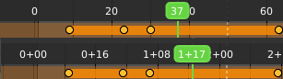
Show Seconds
Show the timing in the timeline area in seconds instead of frames.

Sync visible range
Synchronize the visible timeline range with other visible time based editors.

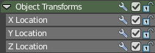
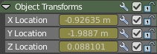
Show Sliders
Shows the value sliders for f-curve channels in the channel list.

Show Group Colors
Display groups and channels with colors matching their corresponding groups (pose bones only currently)
Not documented, not to find out how it works. Not even with bones in pose mode as suggested. This checkbox seems to do nothing

AutoMerge Keyframes
Automatically merge nearby keyframes.

Use High Quality Display
Display the curves in highest quality.

Show Handles
Show the handles at the keyframes.

Only selected Curve Keyframes
Just show the keyframes from the selected curves.

Only Selected Keyframes Handles
Just show the handles of the keyframes from the selected curves.

